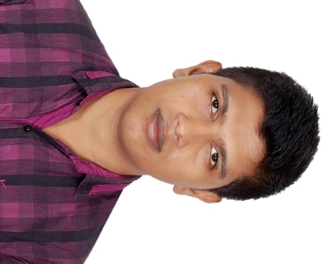**Md. Moshiur Rahman**

Galaxy Tower,

House No-790/401,Road No-1,Sector No-6,

Tushardhara R/A,

Contact No: 01724770595

E-mail: moshiurrahman1724@gmail.com

***Career Objective:***

Looking forward to secure a position in a professional office environment where my skills are valued and I can best utilize my skills and education.

***Educational Qualifications:***

**Masters of Business Administration(MBA)**

Major : Accounting.

Result : 3.37(Out of 4.00).

Institution : Northern University Bangladesh.

Passing Year : 2018.

**Bachelor of Business Administration (BBA)**

Major : Accounting.

Minor : marketing.

Result : 3.00(Out of 4.00).

Institution : Northern University Bangladesh.

Passing Year : 2016.

### Higher Secondary Certificate (H.S.C) Examination.

Group : Business studies.

Result : 4.70 (Out of 5).

Board : Barishal.

Institution : Govt.Syed Hatem Ali College, Barisal.

Passing Year : 2010.

### Secondary School Certificate (S.S.C) Examination.

Group : Business studies.

Result : 4.13 (Out of 5).

Board : Barishal.

Institution : Charkalekhan Ideal SecondaryS School, Barishal.

Passing Year : 2007.

***Acquired Skills on Computer Application:***

|  |  |
| --- | --- |
| Operating System | Microsoft Windows XP,Windows7,Windiws8. |
| Application Software | MS Word, MS Excel, MS Power Point, MS Publisher . |
| Internet | Email, Facebook, Twitter Opening and Basic Browsing. |
| Hardwire | Computer Hardwire setup (Desktop, Laptop) |
| Data Entry | 30 Words/min in English. |

**Language:** Conversation both writing & speaking in Bangla and English.

**Exeperince:**Work as an accountant in one years at Habib International. (03.01.2017 -30.11.2017)

Work as an accountant at Bhuiyan international (02.12.2017-31.03.2018)

***Personal Information:***

**Father’s name:** Md.Siddiqur Rahman.

**Mother’s name:** Mst.Nasrin Sultana.

**Permanent Address**: **Vill:** Charkalekhan, **Post:** Charkalekhan,

**P.S:** Muladi, **Dist:** Barishal.

**Date of Birth:** 4 january, 1993.

**Nationality:**Bangladeshi (by Birth).

**ID No**:19930616923000237

**Blood group**: O+

**Religion:** Islam.

**Marital Status:** Single.

***Interest:***

Reading Magazine, Listening to music,Study.

***Reference:***

**Zahidul Islam**

**UpazilaNirbahi Officer & Executive Magistrate ,Sreenagar, Munshiganj.**

**Mobil no: 01819790406**

**MdMasud Rana**

**Assistant Professor in Accounting**

**Mobil no: 01916214196**

**Northern University Bangladesh**

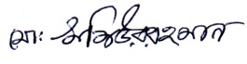

**..……………..………………..**

**Md.Moshiurrahman**